

FACULTY OF INFORMATION MANAGEMENT

UNIVERSITI TEKNOLOGI MARA

NEGERI SEMBILAN, REMBAU

Diploma in Information Management

(IM110 5A)

INTRODUCTION TO WEB CONTENT MANAGEMENT AND DESIGN

(IMD 311)

**GROUP ASSIGNMENT:**

WRITTEN REPORT: -

**CASE STUDY**

Prepared by:

Atirah Binti Idris (2017167827)

Fatin Farhana Binti Mohd Aris (2017512999)

Nur Hafnizah Binti Abd Rasid (2016127583)

Muhammad Ryan Bin Haizar Fariz (2017378187)

Prepared for:

SIR AHMED NOOR KADER MUSTAJIR MD EUSOFF

Date of Submission:

JUNE 2020

**Group Assignment**: -Written Report

**CASE STUDY**

**Prepared by: -**

Atirah Binti Idris (2017167827)

Fatin Farhana Binti Mohd Aris (2017512999)

Nur Hafnizah Binti Abd Rasid (2016127583)

Muhammad Ryan Bin Haizar Fariz (2017378187)

**FACULTY OF INFORMATION MANAGEMENT**

**UNIVERSITI TECHNOLOGY MARA**

**NEGERI SEMBILAN, REMBAU**

**TABLE OF CONTENT**

**CONTENT PAGE**

ACKNOWLEDGEMENT …………………………………………………………….i

1.0 Background of the website…………………………………………………………1-2

2.0 Nature business of the website…………………………………………………….3-4

3.0 UX/UI of the website………………………………………………………………5-6

4.0 Color scheme use…………………………………………………………………..7-8

5.0 Navigation of the website………………………………………………………….9-10

6.0 Content of the website……………………………………………………………..11-12

7.0 REFERENCES…………………………………………………………………….13

**ACKNOWLEDGEMENT**

Assalamualaikum,

First, we would like to recite Alhamdulillah’s and grateful to Allah for giving us the strength, knowledge and His blessing in completing this group assignment and submit it on the due date that had been stated on the assignment paper.

Next, we would like to express our special thanks to our lecturer Sir Kader who gave to us the opportunity to do this assignment.

When we do this assignment, we gain a lot of information. We would also like to expand our deepest gratitude to all those who have directly and indirectly guided us in writing this assignment. Secondly, we would also like to thank our parents and friends who helped us a lot in finalizing this assignment within the limited period. Without helps of the that mentioned above, we would face many difficulties while doing this.

Finally, we would like to thank the authority of University Teknologi Mara (UiTM) for providing us with a good environment and facilities to complete this assignment. Without the good environment and facilities, it impossible for us to accomplish this assignment and it probably not easily done until the due date.

Thank you.

i

**1.0 Background of the website**

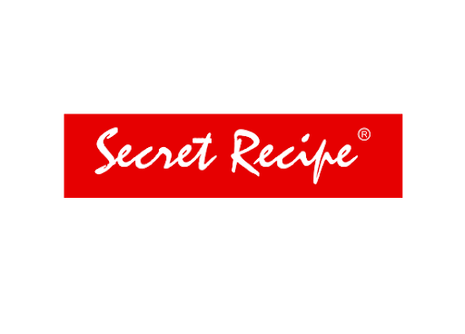

*Figure 1: Secret Recipe’s Company Logo*

Secret Recipe Cakes and Café Sdn Bhd is a Malaysian halal-certified café chain company, it has international branches in Singapore, Indonesia, Thailand, China, Brunei, Cambodia, Myanmar, Maldives and Bangladesh. It serves cakes and fusion food in a service environment. It offers more than 40 types of cakes like cheesecakes, chocolate cakes, brownies. Health cake was introduced to the market as the market shift to healthier lifestyle. Sugar free and trans free cake such as Sugar free moist chocolate cake and Hi-Fibre cream cheesecake gets good review from customer.

* What

As Secret Recipe is a multinational company in ASEAN, it has its own competitors in their business such as Dunkin Brands’, Peet’s, Starbucks. As these companies also sell some same product as secret recipe, it has been a tough competition. As secret recipe sells tastier and delicious dessert it can compete with its competitors. Secret recipe also has good information about marketing through their franchise concept and knew a great deal about how to attract and maintain loyal customers. All the data, information will be provided by the franchisor to maintain their standard of service.

* Who

Founded in 1997 by Yang Bahagia Dato’ Steven Sim who is the owner, founder, Chief Executive Officer and Managing Director of Secret Recipe. Renowned for its extensive range of fine quality gourmet cakes. It has since evolved to become one of the fastest growing lifestyle cakes and café chain in the region with over 440 cafe outlets to date.

1

* When

It was founded in 1997, the company has registered double digit growth for the past five years. On 15 February 2014.

* Where

It has branches in Singapore, Indonesia, Thailand, China, Brunei, Cambodia, Myanmar, Maldives and Bangladesh It serves cakes and fusion food in a service environment. As a leading and largest cafes chain in Malaysia with Halal certification awarded by Jabatan Kemajuan Islam Malaysia (JAKIM). Since its establishment, secret recipe has expanded to over 440 cafes throughout Asia. The company opened branches in Australia, but due to the high costs of starting up a franchise, the operation was ceased. Secret recipe also plans to enter the India and New Zealand markets in the future.

* Why

Secret Recipe promises a value lifestyle proposition of great variety and quality food at affordable prices. The uncompromising quality of food and desserts using quality ingredients, coupled with moderate pricing, has created a new lifestyle cult, comprising of a loyal base of food and cake lovers.

* How

The consumer segmentation gives a big opportunity for secret recipe company to develop their business. The range of target individuals are from 20-40 years old. This will be the better market group as they would like to try more new kind of food. As high demand from customers, the company have high opportunity to open a branch in another area. It will help them to serve the market better and increase the profit. As the trends nowadays people love to dine out, trying new dessert and pamper themselves with small affordable luxuries, secret recipe has the opportunity to serve the larger market and increase their profit.

**2**

**2.0 Nature business of the website**

*Figure 2: The example of Signature cake in secret recipe nature business*

Usually business nature refers to the type or general category of business or commerce you are describing when filling out some form. If you have worked at Secret Recipe, for example, the nature of your business is bakery and food services.

* What

Secret recipe is a form of business service offering intangible products. Service style businesses provide professional skills, expertise and other related products. The products Secret Recipe manufactured are homemade cakes, baked desserts, drinks, fusion foods and many others. There are also providing a service food delivery.

* Who

Online food delivery apps allow customers to order using a single tap on a mobile phone from a wide range of establishments. Customers do not have to call to place an order and then go to a restaurant to pick it up.

3

* When

No more waiting in line or being put on hold. Besides, ordering ahead during a busy day offers flexibility and helps you to pick up food on the go. In addition, you get the entire menu right at your disposal including things that you may not have known existed. It's also easy to track loyalty reward points directly through the app and lead to big savings if you order frequently.

* Where

They can download the application of Secret Recipe to make an order or they can directly order on a Secret Recipe’s website.

* Why

There is business operation to manufacture products or services which can be categorized in different ways which are good manufactured, financial services and capital goods.

* How

The food delivery app receives customer order and sends the request to the nearest restaurant using the app. Then the order is executed. The order is taken by the delivery persons who will deliver the food to the customer concerned.

4

**3.0 UX/UI of the website**

UI/UX design both are work closely. UX design stands for “user experience design”, while UI stands for “user interface design. UI is made up of all the elements that enable someone to interact with a product or service. UX, on the other hand, is what the individual interacting with that product or service takes away from the entire experience. This is a very collaborative process, and the two design teams tend to work closely together. As the UX team is working out the flow of the app, how all of the buttons navigate you through your tasks, and how the interface efficiently serves up the information user’s need, the UI team is working on how all of these interface elements will appear on screen. So, this secret recipe UI/UX is highlighting in graphics and keep it simplicity to attract customers.

* What

Secret recipe’s UX/UI is using logo colors such as white and red as main color for background, provided generous line spacing, and a well-chosen combination of typography with whole lots of pictures to attract user interests.

* Who

Usually an organization will keep it minimalistic look to attract customer attention. In Secret Recipe website used a basic design to ease user/costumer to easily obtain the information that required.

* When

When user/costumer are searching for necessary information or detail of the products, then user/costumer will through the website and FAQ’s for inquiries.

5

* Where

User will able to see stunning pictures as they enter the website, there are transition picture of menu’s available in secret recipe that are worth mouth-watering.

* Why

UX/UI should be simplified so that costumer felt easy to use and purchase the product without any complicity difficulties.

* How

Choosing a good UI/UX will able to enhance the costumer/user experience and boost a lot of good feedbacks reviews therefore will able to obtain more sales.

6

**4.0 Color Scheme Use**

In color theory, a color scheme is the choice of colors used in design for a range of media. For example, the "Achromatic" use of a white background with black text is an example of a basic and commonly default color scheme in web design.

* What

Color scheme is an association of colors based on an organizational system. Basically, it is a set of colors that work well together to create a unified aesthetic. It can find it color scheme using a color wheel, a matrix of colors used to see how colors relate

* Who

Usually an organization will use an interactive color to attract customer attention. In Secret Recipe website used combination of red and white color in their website to attract customer to buy their product.

* When

The best thing Secret Recipe preparing a website color scheme is to get customer attention whenever and as soon as possible because it will leave a positive impression about the website and further progress.

7

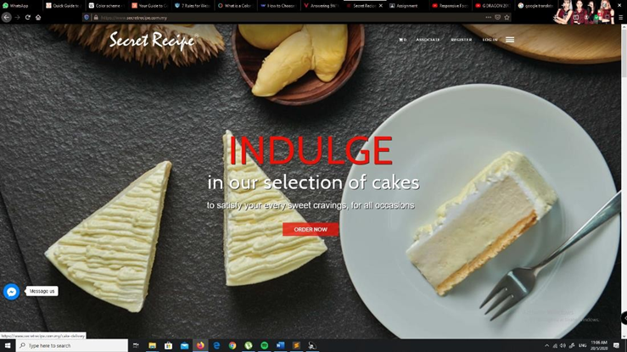

*Figure 3: Showed the combination of scheme color of Secret Recipe website*

* Where

The color scheme in the Secret Recipe’s website is high quality which is the color have a nice combination to each other. It is a good recommendation to select the attractive color which is to entice customer’s attention.

* Why

Scheme color must be an attractive color to make sure that website is responsive color to attract the customer to buy their product.

* How

Choosing a good color scheme for their website could fascinate people or customer to visit Secret Recipe’s website and it could bring triggers emotional responses like excitement, boldness, love and passion.

8

**5.0 Navigation of the website**

Web navigation refers to the method of searching an information resource network in the World Wide Web organized as hypertext or hypermedia, which is facilitates movement from one web page to another web page.

* What

Navigation is often taken for granted, but it plays a crucial role in getting site visitors to view more than just the home page. If navigation choices are unclear, visitors may elect to hit the “Back” button on their first (and final) visit to a Web site.

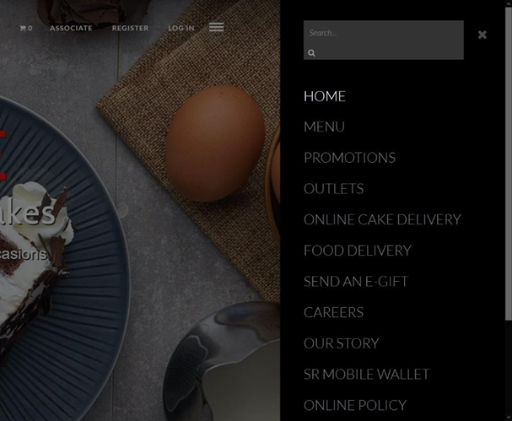

Figure 4: Showed the example of navigation of website of Secret Recipe.

* Who

This navigation will be used by user or customer in their website to ease customer to purchase their product.

9

* When

The navigation will be used when the customer needs to interface with website to use their services that Secret Recipe provided for their customer.

* Why

To increased product purchases, easy to follow directions that are established through strategic website navigation allow customers to effortlessly go through the process of viewing and purchasing products.

* Where

Visitors expect to find horizontal navigation across the top or vertical navigation down the left side. Putting your navigation in standard places makes your site easier to use.

* How

Companies selling more than one product or service will do everything mentioned on categorizing the pages, creating content silos, and interlinking them.

10

**6.0 Content of the websites**

*Figure 5: Menu’s available in Secret Recipe*

The main motive of secret recipe is to provide good product, good service and reasonable price. The factory-based supply method in their franchise system really helps them to keep their product quality. Consistent and they remarkably providing good product all the time throughout all outlet. They hire and train staff off site before opening the outlet and helps the team to educate the small number of staffs more specifically on how to handle the customers by keeping them on priority in each of their service. When staffs trained well, the service they provide is good. Secret recipe sets a reasonable and affordable price on their products. Customers are not forced to buy the whole cake; they are given choice to buy pieces of it as well and the price is reasonable for every piece.

11

* What

That is the secret recipe of a content. It can be in podcasts, video content, animations or infographics, content of websites can be played in any form. By building trust and delivering value to these buyer personas, customers are attracted, converted, closed and delighted. People are lazy in life but alive on social media.

* Who

As a team of professionals working for big company, secret recipe has a multimedia designers and copywriters, to digital marketing experts. Any question you have, they can answer quickly and thoroughly. If you have a problem or concern, they also treat it as an emergency and respond in kind. They will give our all to keep your site online, visible, and driving traffic, 24 hours a day, 7 days a week, and 52 weeks a year.

* When

High demand business like secret recipe needs higher promotion to obtain best result in them

business. Recently Secret Recipe has collaborated with Nestle and RHB Bank to provide Hari Raya promotion in 2018 has increased their number of customers. They offer discounts to promote their outlet. They even collaborated with Panasonic and conducted lucky draw events as it is one of their strategies to promote their business and let it flourish.

* Where

Follow all google guidelines for onsite structure to ensure that Google, Bing, Yahoo, and other search engines can quickly scan, index, and rank the site. This means it will get better exposure in their search results pages, and thus more incoming traffic from visitors searching for what they have offer.

12

* Why

To make sure that the website makes it easy for users to navigate and get the information they want. For a great user experience, secret recipe site’s menu structure it should be intuitive, labelling should be clear, and the language of the site should be free of industry jargon. The graphics and colour scheme should be attractive, uniform, and complementary. However, although the website should be eye-catching, appearance should not trump usability. Instead, appearance and usability should work together to provide a seamless experience.

* How

Secret recipe provides high quality, information rich content that is unique to their business and fitted to each page of your website. Secret recipe help you give your visitors the information they want, and answer many of the questions they have even before they know to ask them. By providing free, valuable content on your site, you engage your visitors, build a level of trust and understanding, and give them all the answers they need to buy from you.

12

**REFERENCES**

[Aisyah Atasha](https://www.slideshare.net/AisyahAtasha?utm_campaign=profiletracking&utm_medium=sssite&utm_source=ssslideview). (Dec 13, 2016). Retrieved on 5 June 2020 from https://www.slideshare.net/AisyahAtasha/slide-cb-secret-recipe

BestWeb Technologies Sdn Bhd. (2011). Retrieved on 5 June 2020 from https://bestweb.com.my/web-design/

Secret Recipe Cakes & Café Sdn Bhd. (2018). Retrieved on 5 June 2020 from https://www.secretrecipe.com.my/our-story/

Originally published by Tripin Studio on. (2020, June 03). What is UI & UX Design? Retrieved June 01, 2020, from https://hackernoon.com/what-is-ui-ux-design-1f01e9dbbf02

13